LONGFORD MUNICIPAL DISTRICT

Corporate Affairs,
Aras an Chontae,
LONGFOIRT.

22nd June 2017.

To: Each Member of the Longford Municipal District.

A Chomhairleoir,

You are requested to attend the Annual Meeting of the Longford Municipal District to be held in the Council Chamber, Aras an Chontae, Great Water Street, Longford on Wednesday, 28th June 2017 at 4.00 p.m. to transact business, as set out on the Agenda hereunder.

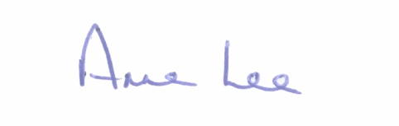
Mise le meas,

_______________
Anne Lee,
Meetings Administrator.

C L A R

1. Election of Cathaoirleach.

2. Election of Leas Cathaoirleach .

3. Fix date and time of Longford Municipal District meetings.

